**UNIVERSIDAD TECNOLÓGICA DE QUERÉTARO**

**CESEQ**



**Diplomado en Software Embebido**

Proyecto Integrador: Control de velocidad de motor CD

10.3. CCRI_20190405

DOCUMENT: Software Development

Document No. #CESEQ_SDP_010.3

Scrum Master: Guarneros, Héctor

Developer. Govea, Francisco

Date (YYYYMMDD): 2019040809

Version: 1.0.0.

Project Version: x.x.x.

## *Cyclomatic Complexity Redundance ADC module*

***DETAILED REPORT ON MODULE***

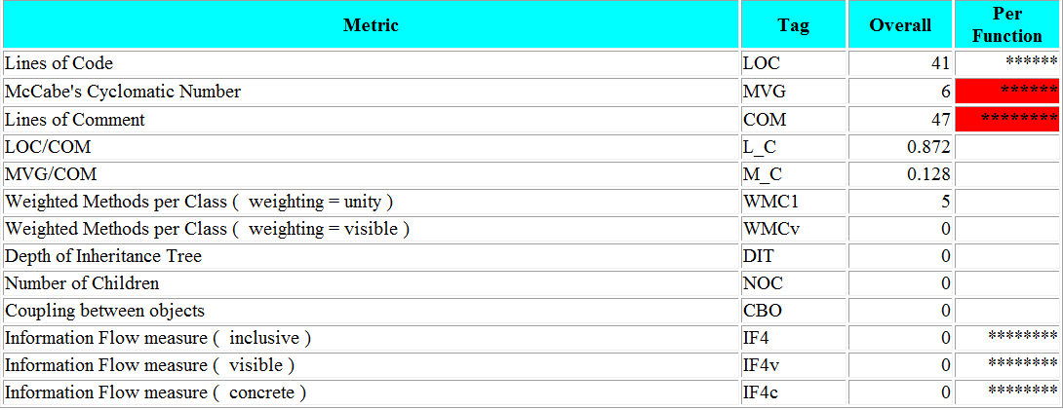

***FUNCTIONS***

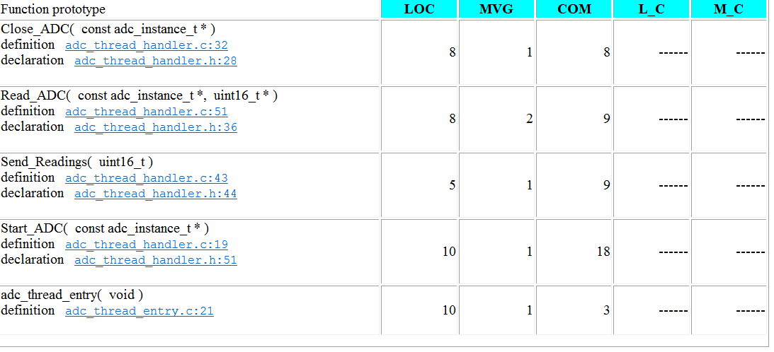

***PROJECT SUMMARY***

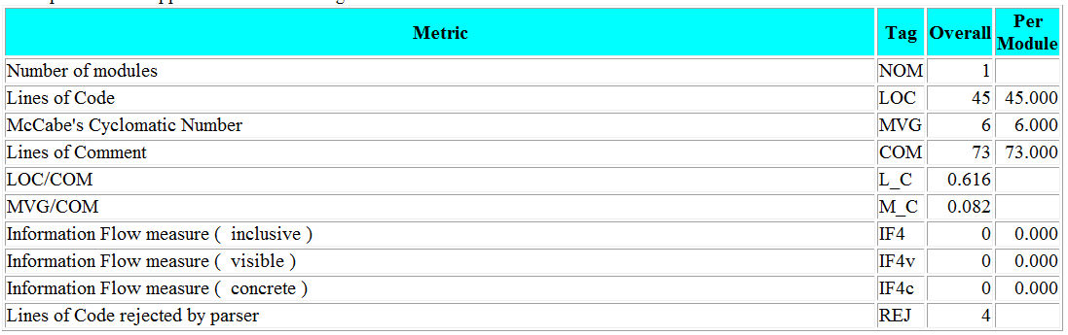

***PROCEDURAL METRICS SUMMARY***



***OBJECT ORIENTED DESIGN***



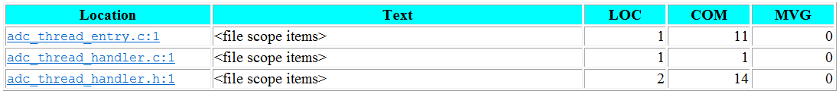

## *Cyclomatic Complexity Redundance PWM module*

***DETAILED REPORT ON MODULE***

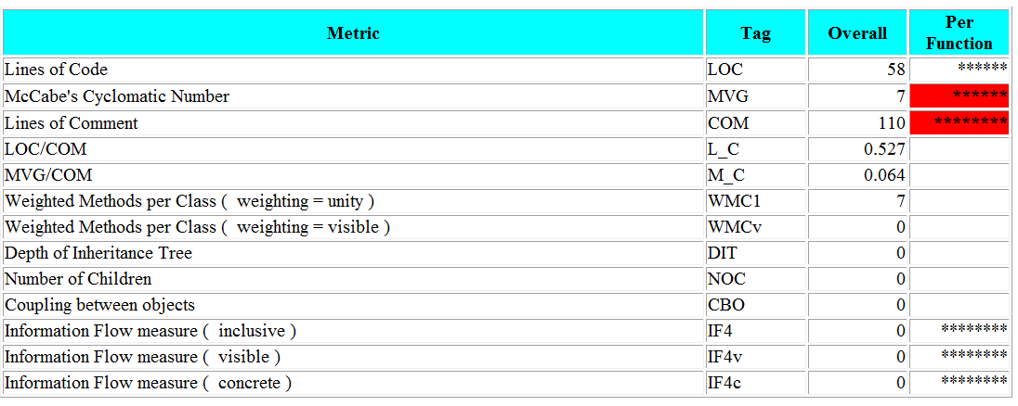

***FUNCTIONS***

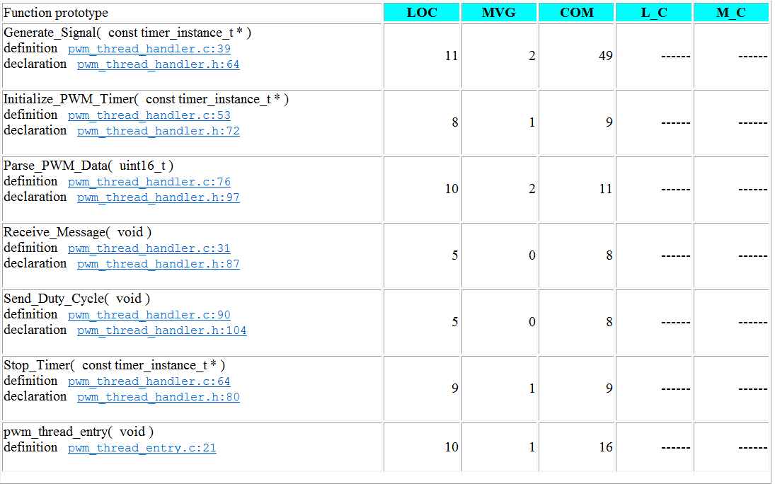

***PROJECT SUMMARY***

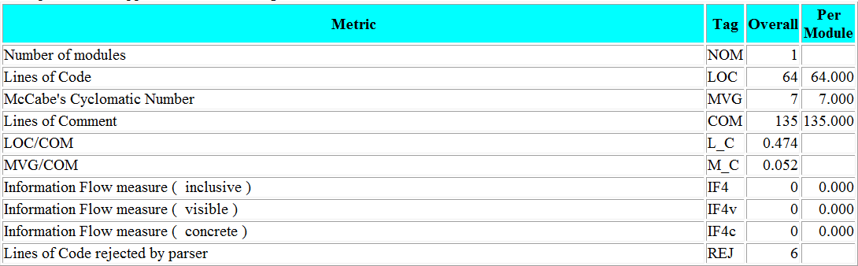

***PROCEDURAL METRICS SUMMARY***



***OBJECT ORIENTED DESIGN***



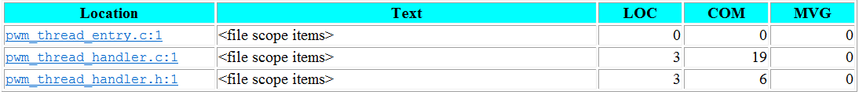

## *Cyclomatic Complexity Redundance ENCODER module*

***DETAILED REPORT ON MODULE***

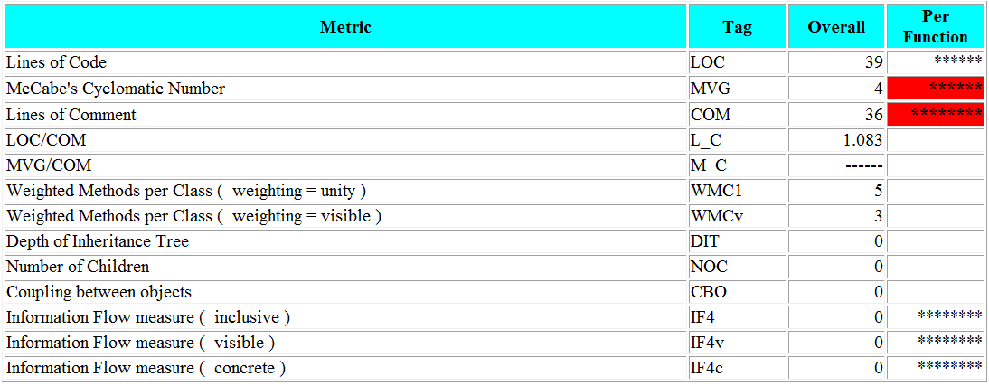

***FUNCTIONS***

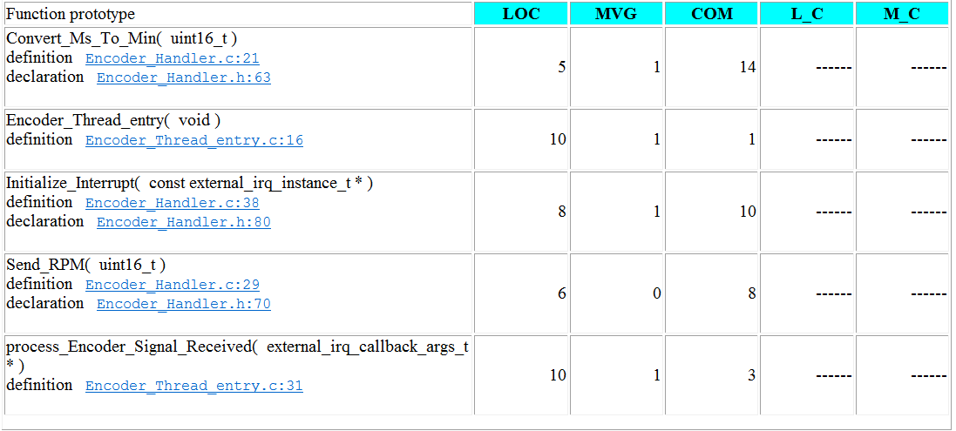

***PROJECT SUMMARY***

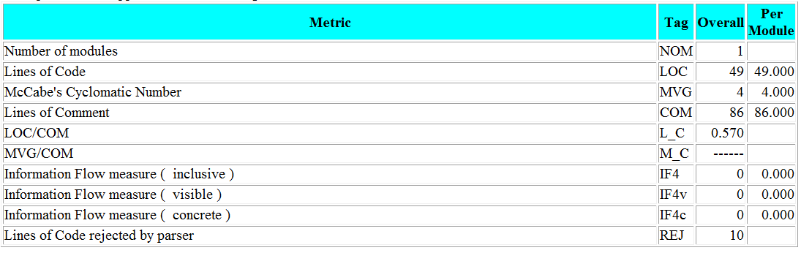

***PROCEDURAL METRICS SUMMARY***



***OBJECT ORIENTED DESIGN***



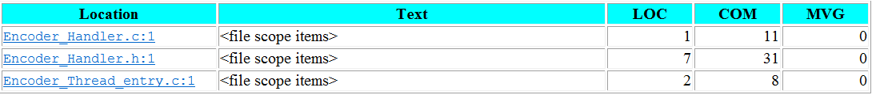

## Cyclomatic Complexity Redundance PID module

***DETAILED REPORT ON MODULE***

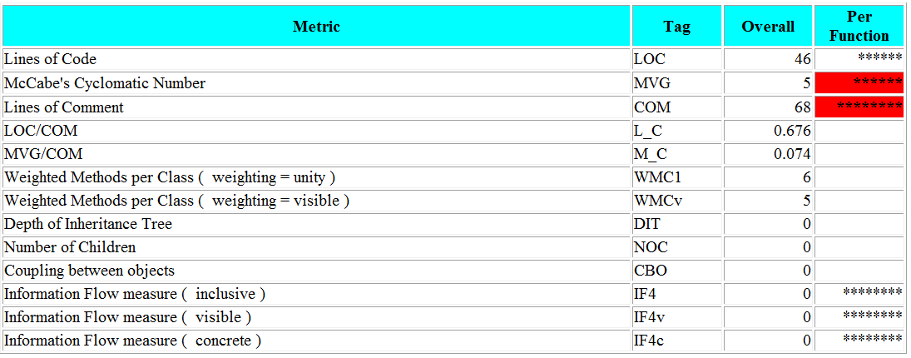

***FUNCTIONS***

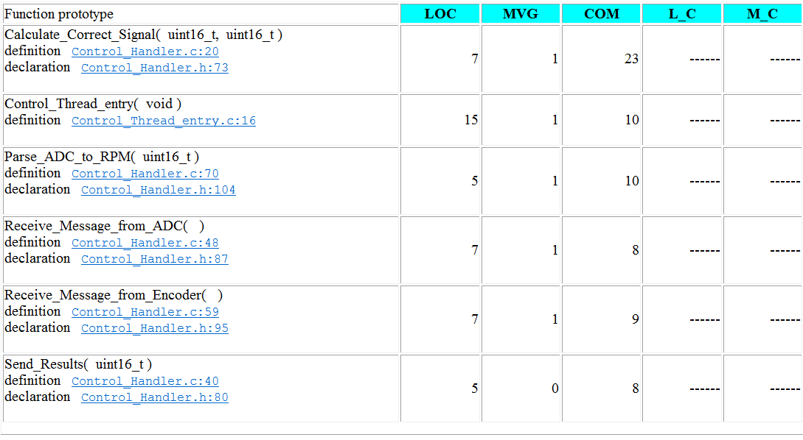

***PROJECT SUMMARY***

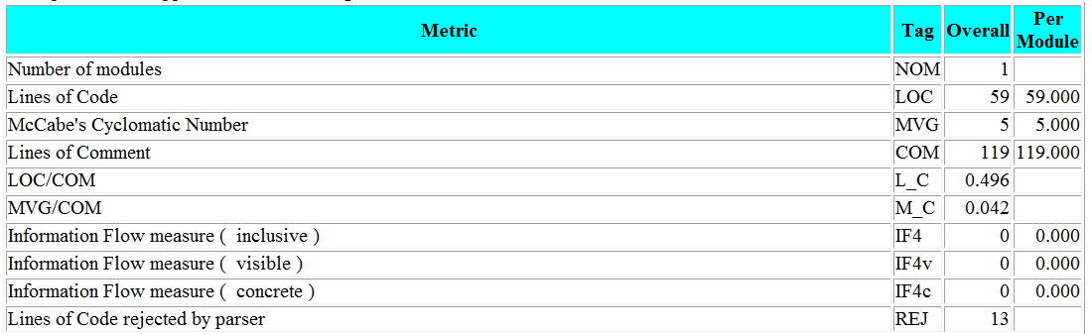

***PROCEDURAL METRICS SUMMARY***



***OBJECT ORIENTED DESIGN***



